PARTIAL DERIVATIVES

## Aim:

* To write Matlab codes to find Partial derivative of a given function f(x,y) at a given point (x1,y1) and also visualize it

We define,

### If f’ is a function of two variables, its partial derivatives are the functions fx and fy defined by

Fx(x,y)= $\lim_{h→0}\left[f\left(x+h,y\right)-f\left(x,y\right)\right]/h$

Fy(x,y)= $\lim_{h→0}\left[f\left(x,y+h\right)-f\left(x,y\right)\right]/h$

**Notation:**

Let z=f(x,y).

The partial derivative fx(x,y) can also be written as

$\frac{∂f}{∂x}(x,y)$ Or $\frac{∂f}{∂x}$

Similarly, fy(xhttp://www.math.hmc.edu/jsMath/fonts/cmmi10/alpha/144/char3B.pngy) can also be written as

$\frac{∂f}{∂y}(x,y)$ Or $\frac{∂f}{∂y}$

The partial derivative fy(xhttp://www.math.hmc.edu/jsMath/fonts/cmmi10/alpha/144/char3B.pngy) evaluated at the point (x0http://www.math.hmc.edu/jsMath/fonts/cmmi10/alpha/144/char3B.pngy0) can be expressed in several ways:

fx(x0,y0), $\frac{∂f}{∂x}|$ (x0,y0), or  (x0,y0)http://www.math.hmc.edu/jsMath/fonts/cmmi10/alpha/144/char3A.png

There are analogous expressions for fy(x0,y0).

**Geometrical Meaning**

Suppose the graph of z=f(x,y) is the surface shown. Consider the partial derivative of f with respect to x at a point (x0,y0).

Holding y constant and varying x, we trace out a curve that is the intersection of the surface with the vertical plane y=y0.

The partial derivative fx(x0,y0) measures the change in z per unit increase in x along this curve. That is, fx(x0,y0) is just the slope of the curve at (x0,y0). The geometrical interpretation of fy(x0,y0) is analogous.

## MATLAB Syntax Used:

|  |  |
| --- | --- |
| diff(f,x) | Differentiate the function with respect to x symbolically |
| R = subs(S, old, new) | Replaces old value with new value in the symbolic expression S. |
| line(X,Y,Z) | Creates a line object in the current axes with default values x = [0 1] and y = [0 1]. You can specify the color, width, line style, and marker type, as well as other characteristics. |
| Y = ones(n) | Returns an n-by-n matrix of 1s. An error message appears if n is not a scalar. |
| set(H,'*PropertyName*',PropertyValue,...) | Sets the named properties to the specified values on the object(s) identified by H. H can be a vector of handles, in which case set sets the properties' values for all the objects |

## MATLAB Code:

Partial Derivatives for functions two variables

1. Initialization:

clc

clear all

format compact

syms x y

z = input('Enter the two dimensional function f(x,y): ');

x1 = input('enter the x value at which the derivative has to be evaluated: ');

y1 = input('enter the y value at which the derivative has to be evaluated: ');

1. Slope Calculation:

z1 = subs(subs(z,x,x1),y,y1)

ezsurf(z,[x1-2 x1+2])

f1 = diff(z,x)

slopex = subs(subs(f1,x,x1),y,y1);

1. Visualization of the plane in which the partial derivative is sought:

[x2,z2]=meshgrid(x1-2:.25:x1+2,0:0.5:10);

y2=y1*ones(size(x2));

hold on

h1=surf(x2,y2,z2);

set(h1,'FaceColor',[0.7,0.7,0.7],'EdgeColor','none')

1. The Tangent line:

t=linspace(-1,1);

x3=x1+t;

y3=y1*ones(size(t));

z3=z1+slopex*t;

line(x3,y3,z3,'color','blue','linewidth',2)

**Practice Problems:**

1. Find the partial derivatives of F(x,y)=x^3+y^3+6xy-1 with respect to y at the point (1,1)

**Output:**

Enter the two dimensional function f(x,y):

x^3+y^3+6*x*y-1

enter the x value at which the derivative has to be evaluated: 1

enter the y value at which the derivative has to be evaluated: 1

z1 = 7

f1 =

3*x^2 + 6*y

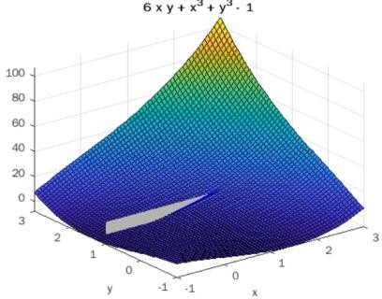

1. Find the partial derivative of F(x,y)=4-x^2-2y^2 with respect to y at the point (1,1)

**Output:**

Enter the two dimensional function f(x,y):

4-x^2-2*y^2

enter the x value at which the derivative has to be evaluated: 1

enter the y value at which the derivative has to be evaluated: 1

z1 = 1

f1 =

-2*x

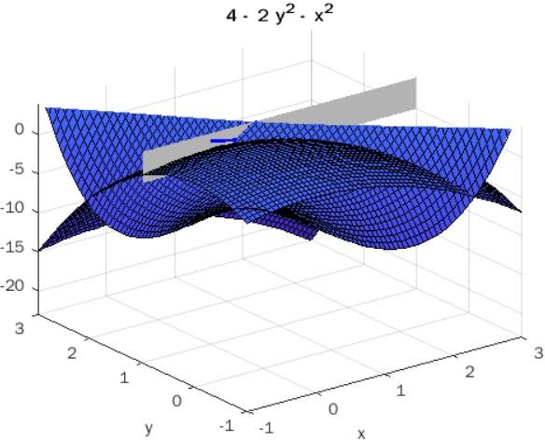

LOCAL MAXIMA AND MINIMA

**Aim:**

* To find the Maximum and Minimum values(Extreme values) for the given function f(x,y) using MATLAB

## Mathematical form:

Let z=f(x,y) be the given function. Critical points are points in the xy-plane where the tangent plane is horizontal. The tangent plane is horizontal, if its normal vector points in the z direction. Hence, critical points are solutions of the equations: fx(x,y)=0 and fy(x,y)=0 .

Procedure for finding the maximum or minimum values of f(x,y):

1. For the given function f(x,y) find and equate it to zero and solve them to find the roots (x1,y1),(x2,y2),- - - - - These points may be maximum or minimum points.
2. Find the values, at these points.
3. (a) If rt-s2>0 and r<0 at a certain point, then the function is maximum at that point

(b)If rt-s2>0 and r>0 at a certain point , then the function is minimum at that point

(c) If rt-s2<0 for a certain point, then the function is neither maximum nor minimum at that point. This point is known as saddle point.

(d) If rt-s2=0 at a certain point, then nothing can be said whether the function is maximum or minimum at that point. In this case further investigation are required

**Example:**

Obtain the maximum and minimum values of f(x,y)=2(x2-y2)-x4+y4

**Solution:** f(x,y)= 2(x2-y2)-x4+y4













|  |  |  |  |  |
| --- | --- | --- | --- | --- |
| **S.No** | **Critical Points** | **r** | **D=rs-t2** | **Remarks** |
| 1 | (0,0) | 4 | -16 < 0 | Saddle Point |
| 2 | (0,1) | 4 | 32 | Minimum |
| 3 | (0,-1) | 4 | 32 | Minimum |
| 4 | (1,0) | -8 | 32 | Maximum |
| 5 | (1,1) | -8 | -64 < 0 | Saddle Point |
| 6 | (1,-1) | -8 | -64 < 0 | Saddle Point |
| 7 | (-1,0) | -8 | 32 | Maximum |
| 8 | (-1,1) | -8 | -64 < 0 | Saddle Point |
| 9 | (-1,-1) | -8 | -64 < 0 | Saddle Point |

The Minimum value of f(x,y) is -1 at (0,1) & (0,-1) and the Maximum value for f(x,y) is +1 at (1,0) & (-1,0)

**MATLAB Syntax used:**

|  |  |
| --- | --- |
| Diff | diff(expr) differentiates a symbolic expression expr with respect to its free variable as determined by symvar. |
| Solve | Symbolic solution of algebraic equations, The input to solve can be either symbolic expressions or strings |
| Size | Dimensions of data and model objects and to access a specific size output. |
| Imag | Imaginary part of complex number, Y=imag(Z) returns the imaginary part of the elements of array Z. |
| Figure | Create figure graphics object, Figure objects are the individual windows on the screen in which the MATLAB software displays graphical output |
| Double | Convert to double precision, double(x) returns the double-precision value for X. If X is already a double-precision array, double has no effect. |
| Sprint | Format data into string. It applies the *format* to all elements of array *A* and any additional array arguments in column order, and returns the results to string *str*. |
| Solve | Symbolic solution of algebraic equations, The input to solve can be either symbolic expressions or strings. |
| Ezsurf | Easy-to-use 3-D colored surface plotter, ezsurf(fun) creates a graph of fun(x,y) using the [surf](jar:file:///C:/Program%20Files/MATLAB/R2010a/help/techdoc/help.jar%21/ref/surf.html) function. fun is plotted over the default domain: -2π <x< 2π, -2π <y< 2π. |
| plot3 | The plot3 function displays a three-dimensional plot of a set of data points. |

**MATLAB Code:**

|  |  |
| --- | --- |
| INPUT | Enter the function f(x,y) |
| OUTPUT | Maxima , Minima values for the given function and Graph for visualizing its solution |

% Local maxima and minima for two variables

clc

clear all

close all

format compact

**%%**

syms x y real

f =input('Enter the function f(x,y): ');

fx = diff(f,x)

fy = diff(f,y)

[ax ay] = solve(fx,fy)

fxx = diff(fx,x)

D = fxx*diff(fy,y) - diff(fx,y)^2%ln-m^2

**%% Collecting critical points**

r=1;

for k=1:1:size(ax)

if ((imag(ax(k))==0)&&(imag(ay(k))==0))

ptx(r)=ax(k);

pty(r)=ay(k);

r=r+1;

end

end

**%% Visulalizing the function**

a1=max(double(ax))

a2=min(double(ax))

b1=max(double(ay))

b2=min(double(ay))

ezsurf(f,[a2-.5,a1+.5,b2-.5,b1+.5])

colormap('summer');

shading interp

hold on

**%% Finding the maximum and minimum values of the function and their visulaization**

for r1=1:1:(r-1)

T1=subs(subs(D,x,ptx(r1)),y,pty(r1))

T2=subs(subs(fxx,x,ptx(r1)),y,pty(r1))

if (double(T1) == 0)

sprintf('The point (x,y) is (%d,%d) and need further investigation', double(ptx(r1)),double(pty(r1)))

elseif (double(T1) < 0)

T3=subs(subs(f,x,ptx(r1)),y,pty(r1))

sprintf('The point (x,y) is (%d,%d) a saddle point', double(ptx(r1)),double(pty(r1)))

plot3(double(ptx(r1)),double(pty(r1)),double(T3),'b.','markersize',30);

else

if (double(T2) < 0)

sprintf('The maximum point(x,y) is (%d, %d)', double(ptx(r1)),double(pty(r1)))

T3=subs(subs(f,x,ptx(r1)),y,pty(r1))

sprintf('The value of the function is %d', double(T3))

plot3(double(ptx(r1)),double(pty(r1)),double(T3),'r+','markersize',30);

else

sprintf('The minimum point(x,y) is (%d, %d)', double(ptx(r1)),double(pty(r1)))

T3=subs(subs(f,x,ptx(r1)),y,pty(r1))

sprintf('The value of the function is %d', double(T3))

plot3(double(ptx(r1)),double(pty(r1)),double(T3),'m*','markersize',30);

end

end

end

## Practice Problems:

1. Find the maximum and minimum value of F(x,y)= 2x3+xy^2+5x2+y2

**Output:**

Enter the function f(x,y): 2*x^3+x*y^2+5*x^2+y^2

a1 =

0

a2 =

-1.6667

b1 =

2

b2 =

-2

ans =

'The minimum point(x,y) is (0, 0)' T3 =

0

ans =

'The value of the function is 0' T3 =

3

ans =

'The point (x,y) is (-1,-2) a saddle point' T3 =

3

ans =

'The point (x,y) is (-1,2) a saddle point' ans =

'The maximum point(x,y) is (-1.666667e+00, 0)' T3 =

125/27

ans =

'The value of the function is 4.629630e+00'

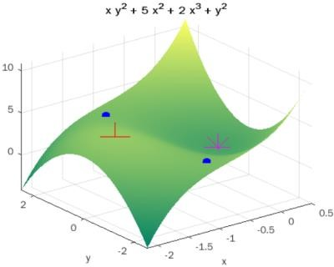

1. Find the local maximum and minimum values of f(x,y)=2(x2-y2)-x4+y4

**Output:**

Enter the function f(x,y): 2*(x^2-y^2)-x^4+y^4

a1 =

1

a2 =

-1

b1 =

1

b2 =

-1

T3 = 0

ans =

'The point (x,y) is (0,0) a saddle point' ans =

'The maximum point(x,y) is (-1, 0)' T3 =

1

ans =

'The value of the function is 1'

ans =

'The maximum point(x,y) is (1, 0)' T3 =

1

ans =

'The value of the function is 1' ans =

'The minimum point(x,y) is (0, -1)' T3 =

-1

ans =

'The value of the function is -1' ans =

'The minimum point(x,y) is (0, 1)' T3 =

-1

ans =

'The value of the function is -1' T3 =

0

ans =

'The point (x,y) is (-1,-1) a saddle point' T3 =

0

ans =

'The point (x,y) is (1,-1) a saddle point' T3 =

0

ans =

'The point (x,y) is (-1,1) a saddle point' T3 =

0

ans =

'The point (x,y) is (1,1) a saddle point'

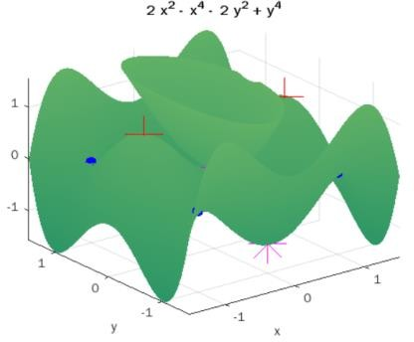

Lagrange Multipliers

1. **Initialization:**

syms x y lam real

f= x^2+2*y^2 %input('Enter f(x,y) to be extremized : ');

g= x^2+y^2-1 %%input('Enter the constraint function g(x,y) : ');

1. **Computing Partial derivatives and finding the critical points:**

F=f-lam*g

Fx=diff(F,x)

Fy=diff(F,y)

[ax,ay,alam]=solve([Fx,Fy,g],x,y,lam)

ax=double(ax)

ay=double(ay)

**%% Collecting critical points**

r=1;

for k=1:1:size(ax)

if ((imag(ax(k))==0)&&(imag(ay(k))==0))

ptx(r)=ax(k);

pty(r)=ay(k);

r=r+1;

end

end

1. **Computing the values at the critical points**

ax=ptx

ay=pty

T = subs(f,{x,y},{ax,ay})

T=double(T)

epx=3

epy=3

figure (1)

for i = 1:length(T)

D=[ax(i)-epx ax(i)+epx ay(i)-epy ay(i)+epy]

fprintf('The critical point (x,y) is (%1.3f,%1.3f).',ax(i),ay(i))

fprintf('The value of the function is %1.3f\n',T(i))

ezcontour(f,D)

hold on

h = ezplot(g,D);

set(h,'Color',[1,0.7,0.9])

plot(ax(i),ay(i),'k.','markersize',15+2*i)

end

1. **Finding the Maximum and minimum at those points:**

f_min=min(T)

f_max=max(T)

## Practice Problems:

1. **Find the extreme values of the function** (𝒙, 𝒚) = 𝟑𝒙 + 𝟒𝒚 **on the circle** 𝒙𝟐 + 𝒚𝟐 = 𝟏.

**Output:**

Enter f(x,y) to be extremized : 3*x+4*y

Enter the constraint function g(x,y) : x^2+y^2-1

Fd =

[3 - 2*lam*x, 4 - 2*lam*y, - x^2 - y^2 + 1] ax =

-3/5

3/5

ay =

-4/5

4/5 alam =

-5/2

5/2

T =

-5

5

T =

-5

5

epyu =

0.8000

D =

-1.1000 1.1000 -1.3000 1.3000

The critical point (x,y) is (-0.600,-0.800).The value of the function is -5.000 The critical point (x,y) is (0.600,0.800).The value of the function is 5.000

TT =

-5

5

f_min =

-5

f_max = 5

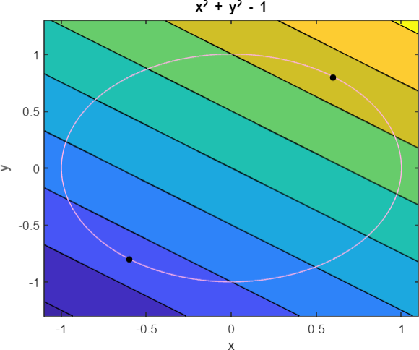

1. Find the extreme values of the function (𝒙,)**=**xy on the ellipse 𝑥2 + 𝑦2 = 1.

8 2

**Output:**

Enter f(x,y) to be extremized :

x*y

Enter the constraint function g(x,y) : (x^2)/8+(y^2)/2-1

Fd =

[y - (lam*x)/4, x - lam*y, - x^2/8 - y^2/2 + 1] ax =

2

-2

-2

2

ay =

-1

1

-1

1

alam =

-2

-2

2

2

T =

-2

-2

2

2

T =

-2

-2

2

2

epyu =

1

D =

-2.5000 2.5000 -1.5000 1.5000

The critical point (x,y) is (2.000,-1.000).The value of the function is -2.000 The critical point (x,y) is (-2.000,1.000).The value of the function is -2.000 The critical point (x,y) is (-2.000,-1.000).The value of the function is 2.000 The critical point (x,y) is (2.000,1.000).The value of the function is 2.000 TT =

-2

-2

2

2

f_min =

-2

f_max =

2

